Fibers are used in forensic science to create a link between crime and suspect
- Trace evidence
- Collecting fibers within 24 hours is critical (95% lost)
- Shedding—common form of fiber transfer
- Microscopic Analysis
- IR, florescent, refraction spectroscopy
- Destructive Testing Methods
  - Burn Analysis
  - Chemical Analysis

Chapter 4: A Study of Fibers and Textiles
By the end of this chapter you will be able to:
- Identify and describe common weave patterns of textile samples
- Compare and contrast various types of fibers through physical and chemical analysis
- Describe principle characteristics used to identify common fibers (microscopic)
- Apply forensic science techniques to analyze fibers (burn analysis)
- Properly operate Bunsen burner

Common Weave Patterns
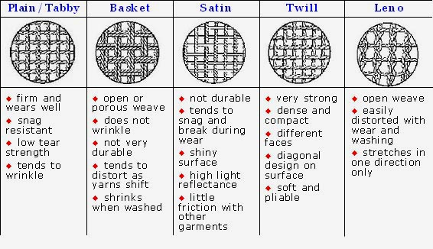
- Yarns—fibers (of any length, thick or thin, loose or tight) twisted or spun together
- Blending fibers meets different needs
(e.g., resistance to wrinkling)
- Fibers are woven into fabrics or textiles
  - Threads are arranged side by side (the warp)
  - More threads (the weft) are woven back and forth crosswise through the warp

Natural Fibers
Many different natural fibers that come from plants and animals are used in the production of fabric.
Plant fibers (seed, stem/leaves, fruit):
- Cotton—most common textile
plant fiber (picture)
- Coir – coconut covering; is durable
- Linen – flax stem
- Hemp & jute from stems grow in bundles.
- Manila fiber from abaca plant leaves
Animal fibers (made of proteins):
- Wool and cashmere from sheep
- Mohair from goats
- Angora from rabbits
- Hair from alpacas, llamas, and camels

- Silk from caterpillar cocoons Bombyx mori (longer fiber does not shed easily)
Mineral Fibers:
- Fiberglass—a fibrous form of glass; Used to insulate buildings
- Asbestos—a crystalline structure; Used for building material

Cotton
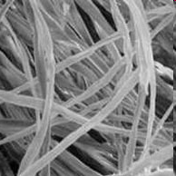

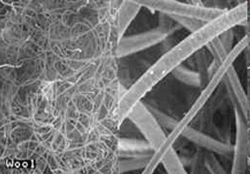
Wool

Cross-section of a man-made fiber


Synthetic Fiber
More than half of all fibers used in the production of textile materials are synthetic or man-made. Nylon, rayon, and polyester are all examples of synthetic fibers.
Regenerated Fibers (derived from cellulose):
- Rayon
  - Most common in this group
  - Imitates natural fibers, but stronger
- Celenese®
  - Cellulose chemically combined with acetate
  - Found in many carpets
- Polyamide nylon
  - Cellulose combined with three acetate units
  - Breathable and lightweight
  - Used in performance clothing
Synthetic Polymer Fibers
-Petroleum base
-Monomers join to form polymers
-Uniform diameters
- Polyester
- “Polar fleece” (Polyethylene terephthalate (PET))
- First made to mimic wool
- Wrinkle-resistant
- Not easily broken down by light or concentrated acid
- Added to natural fibers for strength
- Nylon
- Easily broken down by light and concentrated acid
- Otherwise similar to polyester

Comparison of Natural and Synthetic Fibers
